**CMPE-277: Smartphone application Development**

**Assignment 3 – Farm IOT App**

**Submitted to:** Prof. Chandrasekar Vuppalapati

**Submitted by:** Anvit Saxena (SJSU ID: 010953436)



In this assignment, we demonstrate the concept of Broadcast Receiver using a Farm based IOT Application. I have created two different applications, first one gets the values of temperature and Humidity from user and second application receives the broadcast from first application to take further actions. Following are the steps along with screenshots that explains in detail:

**Step 1:** The first application “Broadcast Demo” as shown below has one main activity with two fields, one to enter Temperature and other to enter Humidity.

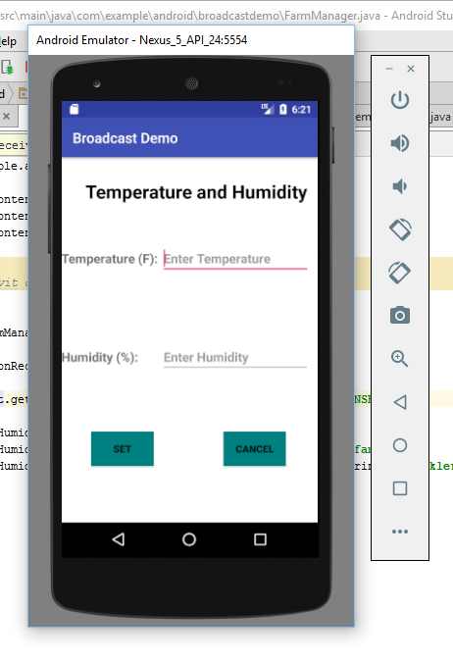

**Step 2:** The temperature and humidity is entered by the user and the “Set” button is clicked as shown below:

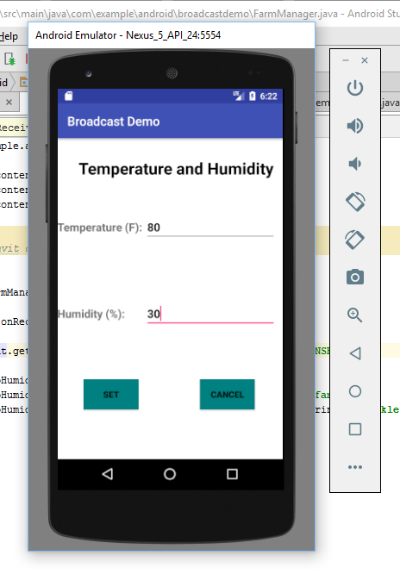

**Step 3:** Once the Set button is clicked in first application, a broadcast is sent to second application which shows the user entered temperature and humidity values and further actions to take by the Farm Manager.

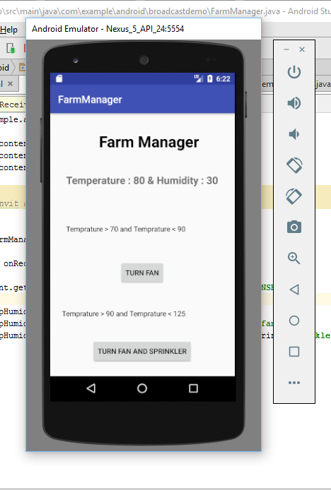

**Step 4:** Now based on the conditions mentioned in the second application, the farm manager will turn on the fan or both fan and sprinkler by clicking on given buttons and the next screen will show the status as shown below:

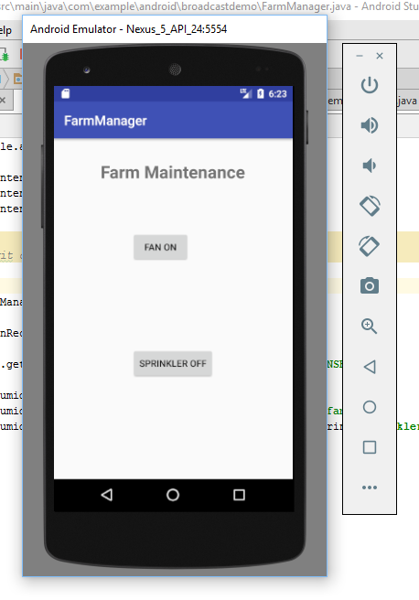

**Example:**

